

Applied DevOps

Phase 02__Task 03



November 1, 2023

Tayyab Shahid

19F-0911

# **Phase 02(Task 03):**

## **Setup a Vagrant + Ansible project to deploy the project on VMs**

* Vagrant Install

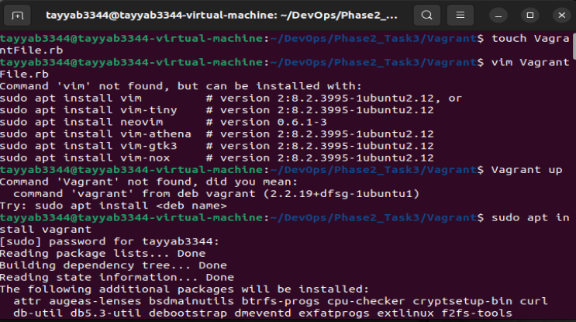

* Virtual Box Install
* Ubuntu/Trusty64 setting

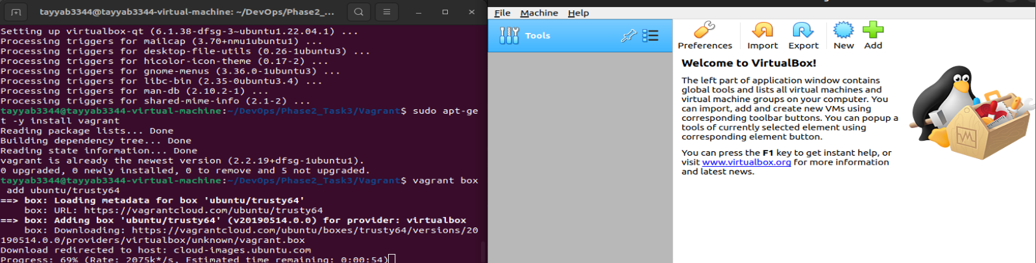

* Vagrant init
* Vagrant up

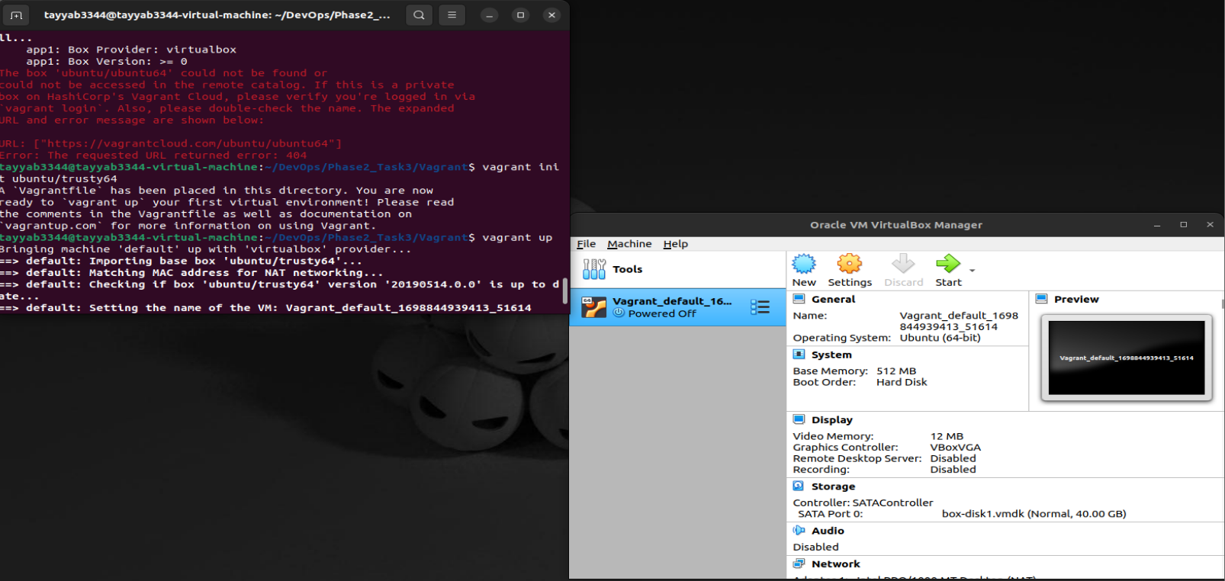

* Ansible Install

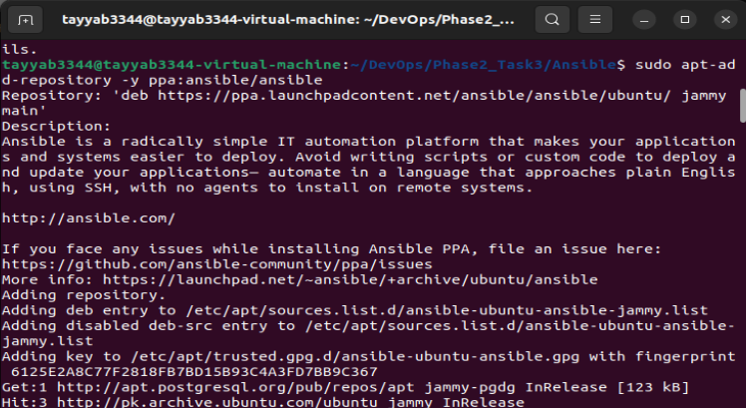

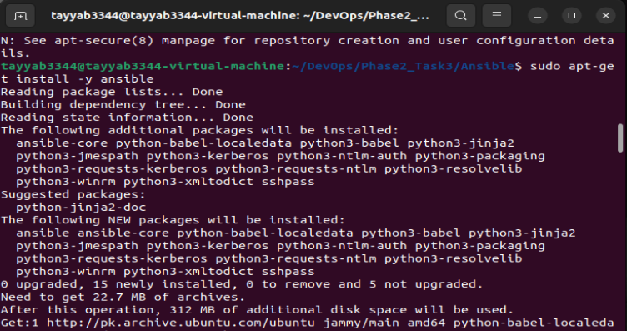

* Python3-PIP install

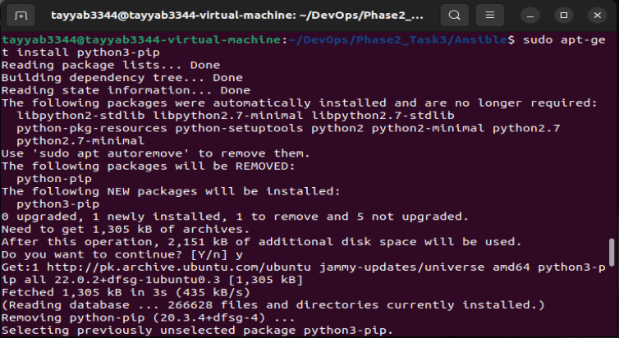

* Boto, boto3 install

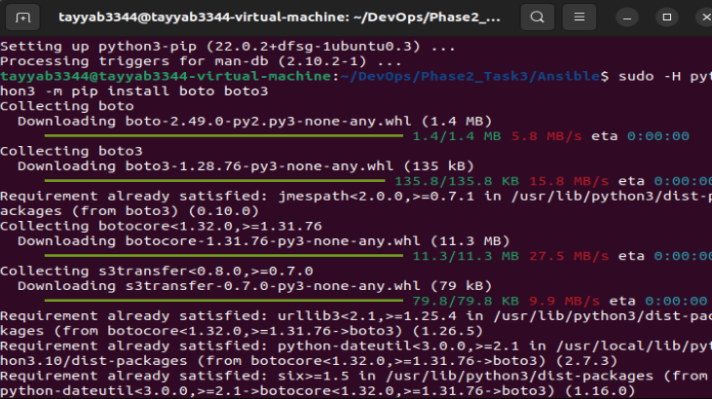

* Ansible Installed

